**OUTPUTS:**

# Eclipse

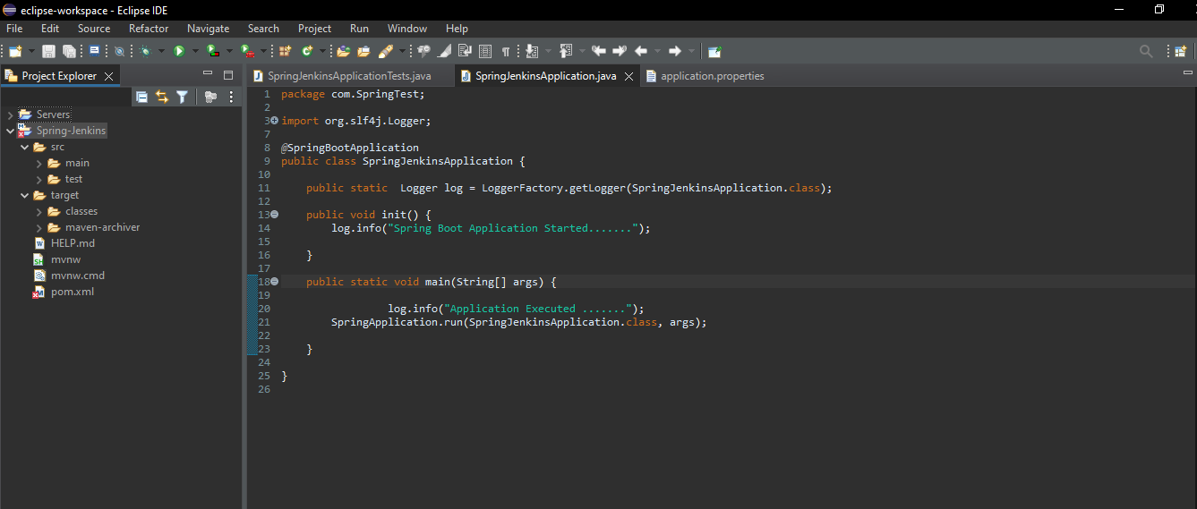

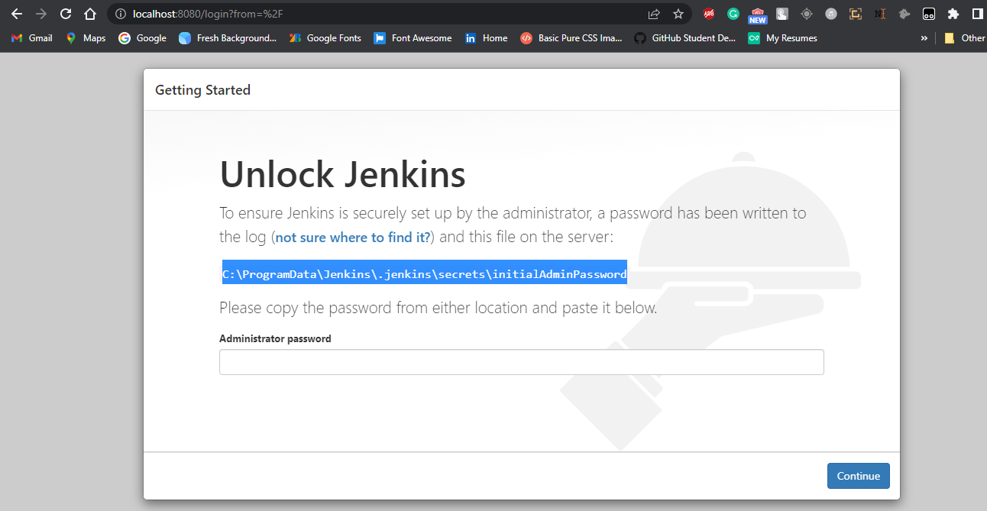

# I create Simple Spring boot Application to build a CI/CD pipeline to demonstrate continuous deployment:

## 

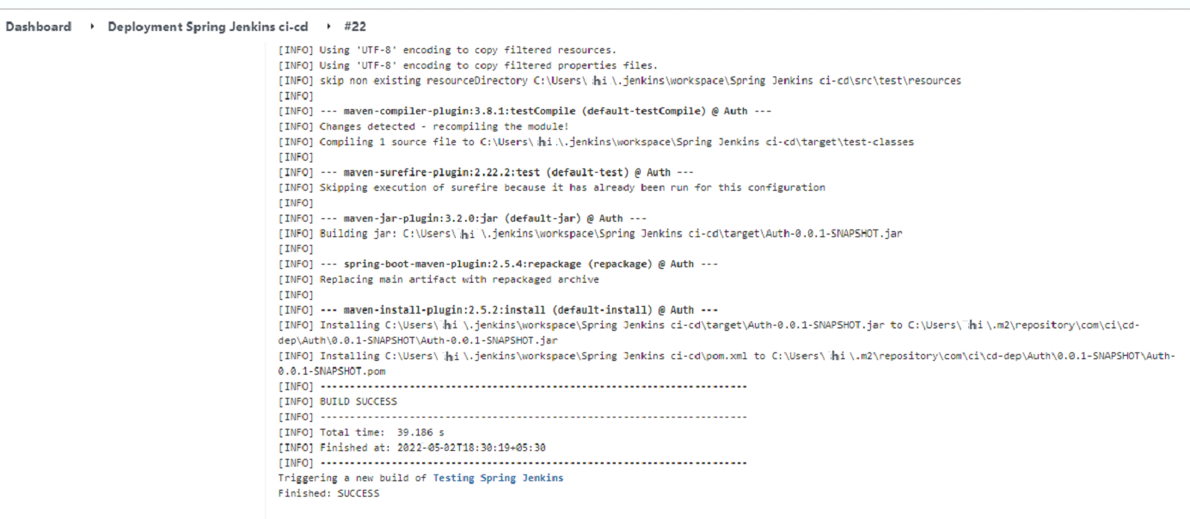

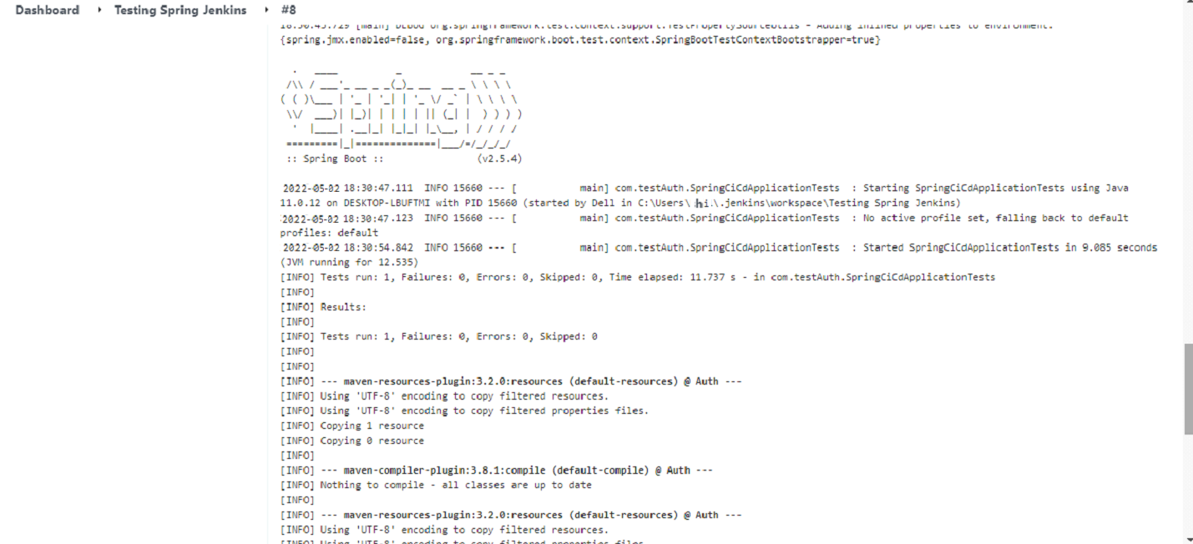

# Git Hub: Application Deploy on git Hub

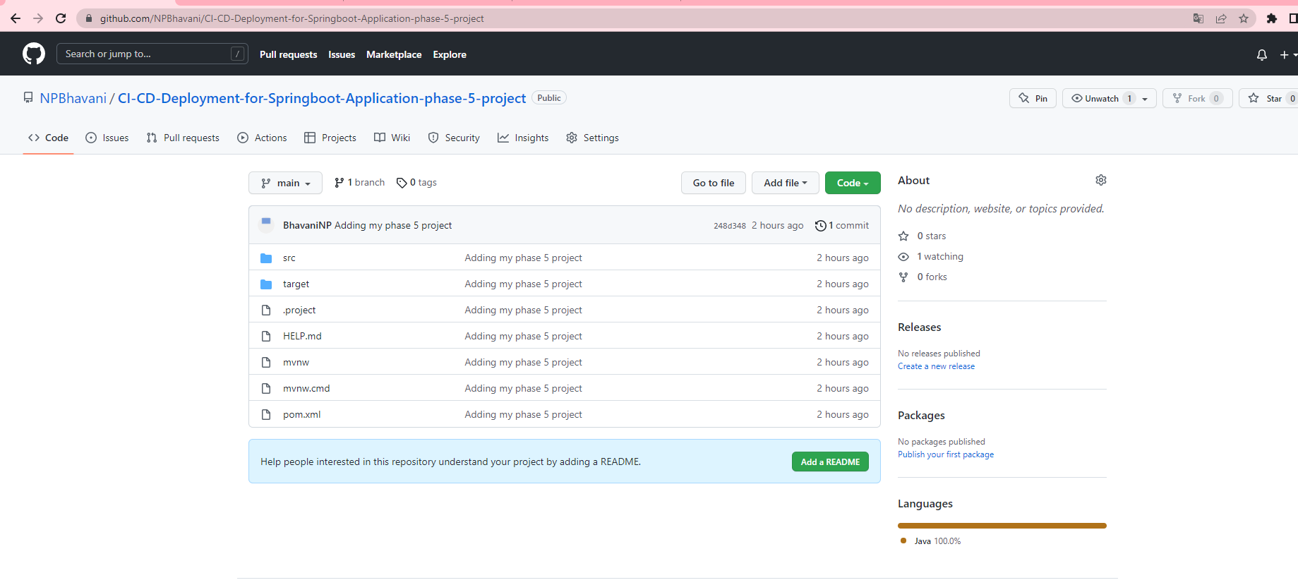

# Jenkins : Run Jenkins

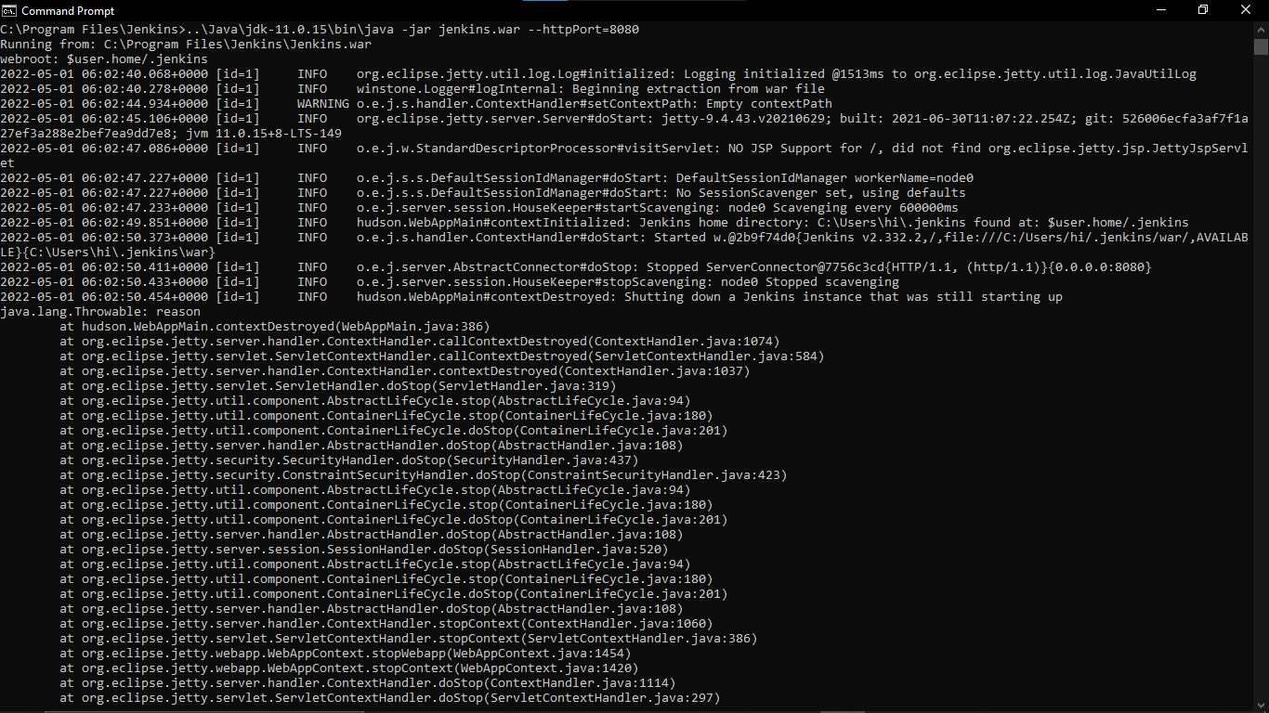

**CREATE THREE JENKINS PROJECT DEPLOYMENT:-**

**DEPLOYMENT-TESTING-PRODUCTION**

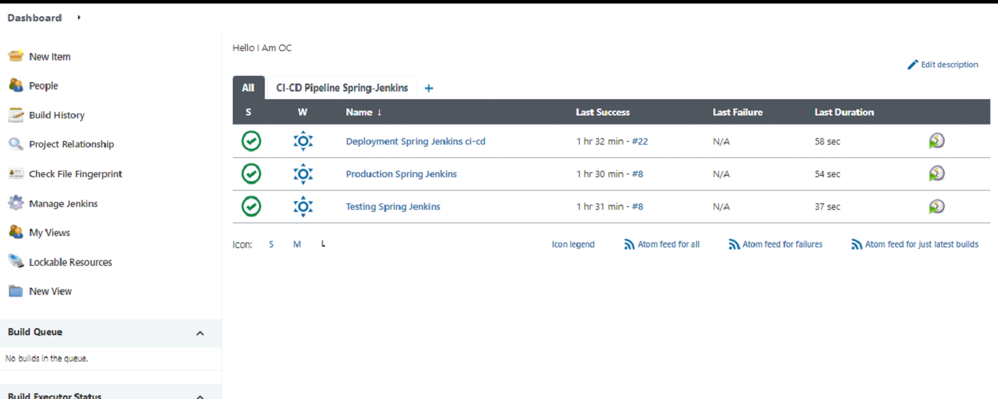



**Final Output:-**

**Last host the application on AWS EC2 instance:**

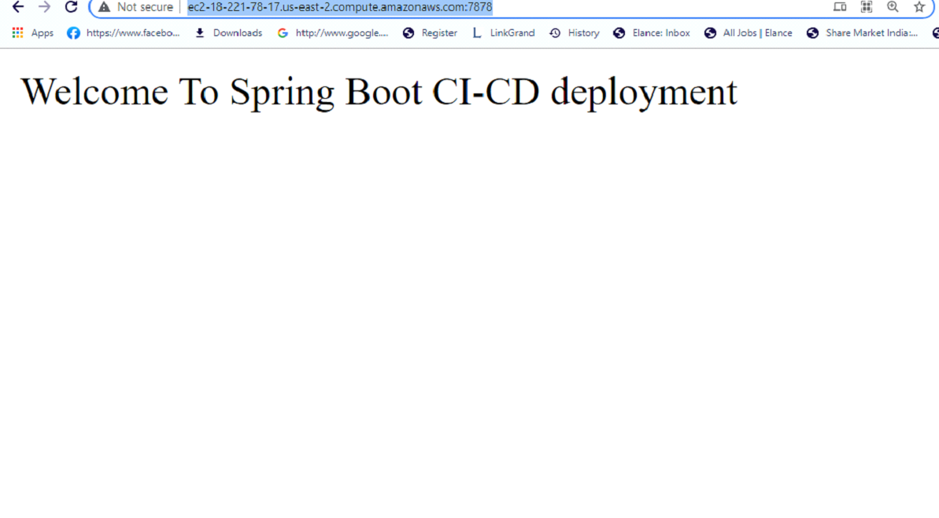

## **Step 2:** **Pushing the code to GitHub repository**

* Open your command prompt and navigate to the folder where you have created your files.

*cd <folder path>*

* Initialize repository using the following command:

*git init*

* Add all the files to your git repository using the following command:

*git add .*

* Commit the changes using the following command:

*git commit . -m <commit message>*

* Push the files to the folder you initially created using the following command:

*git push -u origin master.*